NCL 2020 Team Game

|  |
| --- |
| * This is an individual or group assignment, and worth 20 points. * One submission per team is required. * Make screenshots readable. |

# Game outcome

|  |  |  |
| --- | --- | --- |
| **No** | **Name** | **Role** |
| 1 | Mohammed Al Madhi | Team Owner (Password Cracker, Open Source Intelligence, Network Traffic Analysis) |
| 2 | Daniel Kearl | Pro (Cryptography, Log Analysis, Web Application Exploitation, Scanning Reconnaissance)_ |
| 3 | Asmayt Zeru | Helper (Enumeration and Exploitation, Forensics and Survey) |

Screenshot #1

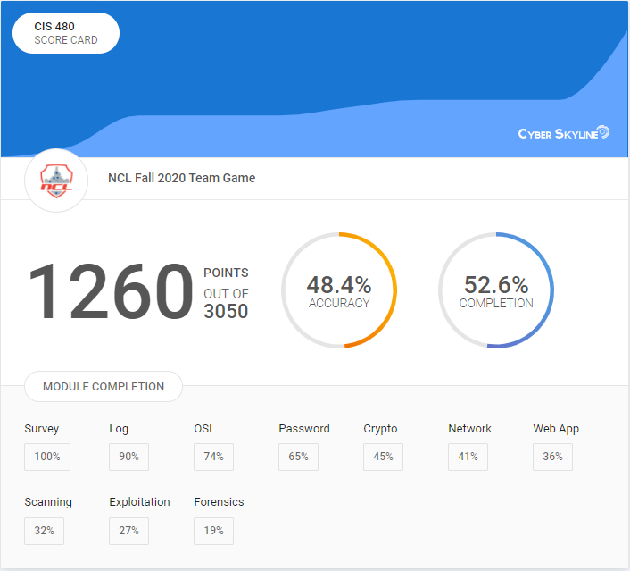

Screenshot #2

